Cricket Scorecard

Aim: -
The aim of this project is to create a basic cricket scorecard to calculate the runs scored by a batsman.

Research: -
Cricket is sport that started in the late 16th Century and was fully established until the 18th Century.
As the sport slowly started getting established, systems were required to properly play the sport.
Thus the system of scorekeeping began.
This system consisted of many different things, such as information about both the teams, batsmen, bowler, runs scored by each etc.
Thus slowly the system of scorekeeping began standard wherever the sport was being played.
This ensured competition between the teams, thus upholding the spirit of the game.

References:
1. https://en.wikipedia.org/wiki/History_of_cricket
2. https://yesterdaymatch.com/cricket-scorecards-explained-step-by-step-beginners/
Analysis: -
The scorecard is colloquially known as The Book.
Using the book, the scorer fills out two main sections per ball, the bowling analysis and the batting analysis.
Each section helps track the number of balls bowled in an over, any extras (such as Wide Balls and No Balls) and also any wickets (or dismissals).
At the end of each over, the scorer may fill in an over analysis with the score at the end of the over, the number of wickets that have fallen, any penalties incurred and the number of the bowler in the analysis.
This is the defined system of scorekeeping.
In modern times, this process can be computerized using various programs and programming languages.
In this program, I have used C programming language to create a basic scoresheet to calculate the runs scored by a single batsman.

Ideate: -
The program inputs marks of 5 subjects through an array by the use of control statement ([for] loop).
Then it finds the size of the given array by sizeof () function, by dividing the size of complete array (in bytes) by a single unit.
Then it sends both the values to the recursive function by use of pointers and then sum is calculated and displayed on the output screen.

Build: -

#include<stdio.h>

int score(int *runs, int runs_size)
{
if(runs_size == 0)
{
return 0;
}
else
{
return *runs + score(runs + 1, runs_size - 1);
}
}

int main()
{
int runs[5];
printf("Enter runs scored by the batsman: ");

for(int i = 0;i < 5;i++)
{
scanf("%d", &runs[i]);
}

int runs_size = sizeof(runs) / sizeof(runs[0]);

int total = score(runs,runs_size);

printf("Total Score is: %d", total);
}

Testing: -
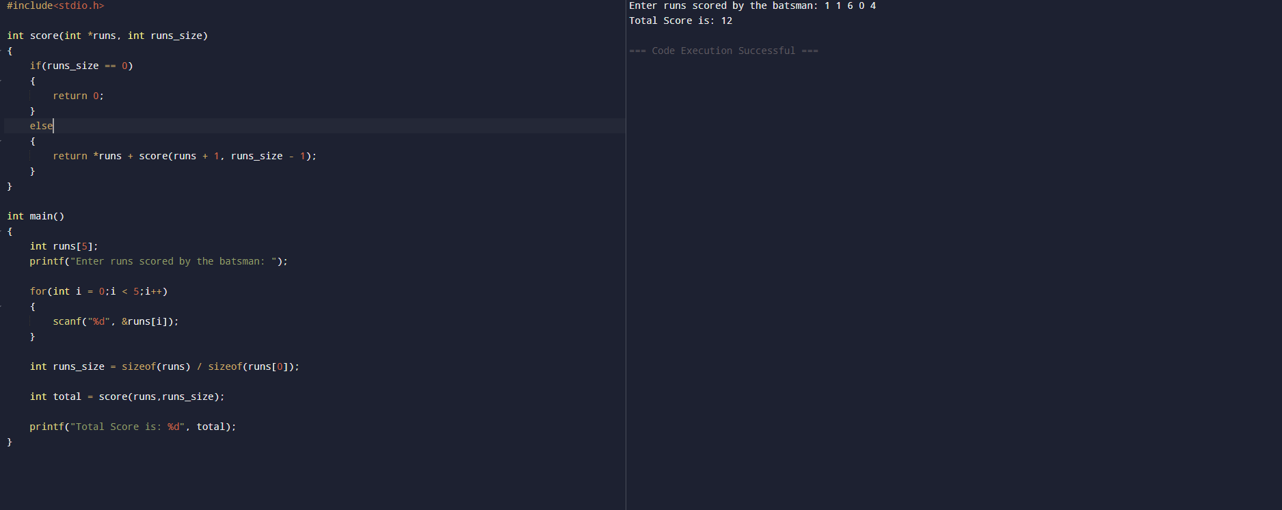
Implementation: -

Conclusion: -
Thus, the program gives the addition for runs scored by a batsman.
Therefore, it completes the objective.

